

Practices for Secure Software Report

Table of Contents
Document Revision History 3
Client 3
Instructions 3
Developer 4
1. Algorithm Cipher 4
2. Certificate Generation 4
3. Deploy Cipher 4
4. Secure Communications 4
5. Secondary Testing 4
6. Functional Testing 4
7. Summary 4
8. Industry Standard Best Practices 4

Document Revision History

Version | Date | Author | Comments
1.0 | 21 June 2026 | Jeff Roys

Client



Instructions

Submit this completed practices for secure software report. Replace the bracketed text with the relevant information. You must document your process for writing secure communications and refactoring code that complies with software security testing protocols.

- Respond to the steps outlined below and include your findings.
- Respond using your own words. You may also choose to include images or supporting materials. If you include them, make certain to insert them in all the relevant locations in the document.
- Refer to the Project Two Guidelines and Rubric for more detailed instructions about each section of the template.

Developer
Jeff Roys

Algorithm Cipher

For this project, I used the SHA-256 cryptographic hash algorithm to create a checksum verification step for Artemis Financial. SHA-256 is part of the SHA-2 family of secure hash algorithms. It takes input data and creates a fixed 256-bit hash value. This hash value can be used to verify that the original data has not been changed. If the input changes even slightly, the checksum output will be different.
SHA-256 is not the same thing as encryption because it is a one-way hash function. Encryption is meant to be reversed with the correct key, but a hash is meant to verify integrity. This makes SHA-256 a good choice for this project because Artemis Financial needs a checksum verification step to confirm data integrity. The application takes the data string and creates a SHA-256 checksum that can be displayed through the /hash endpoint.

Random numbers and symmetric or asymmetric keys are more directly related to encryption and certificate use than to the SHA-256 checksum itself. Symmetric encryption uses one shared key, while asymmetric encryption uses a public and private key pair. In this project, the self-signed certificate supports HTTPS communication, while the SHA-256 hash supports data verification. Together, these provide stronger protection by adding secure communication and checksum verification.
Encryption and hashing algorithms have changed over time as older methods have become easier to attack. Older algorithms such as MD5 and SHA-1 are no longer considered strong enough for secure systems because they have known weaknesses. SHA-256 is still widely used today because it provides a stronger 256-bit hash and is considered appropriate for secure checksum verification.

Certificate Generation
Insert a screenshot below of the CER file.

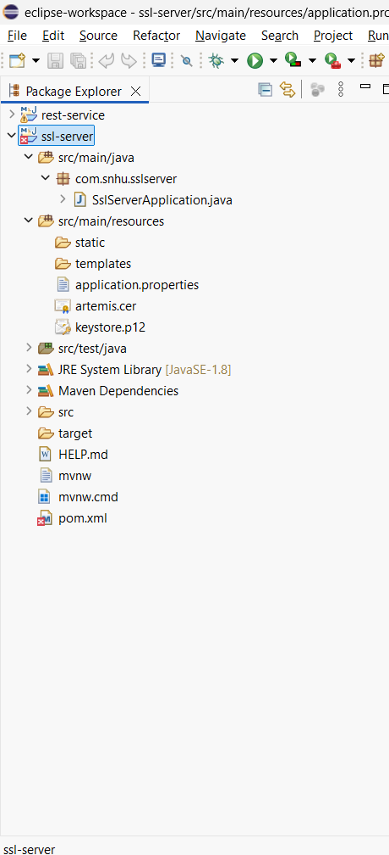

Deploy Cipher
Insert a screenshot below of the checksum verification.



Secure Communications
Insert a screenshot below of the web browser that shows a secure webpage.



Secondary Testing
Insert screenshots below of the refactored code executed without errors and the dependency-check report.
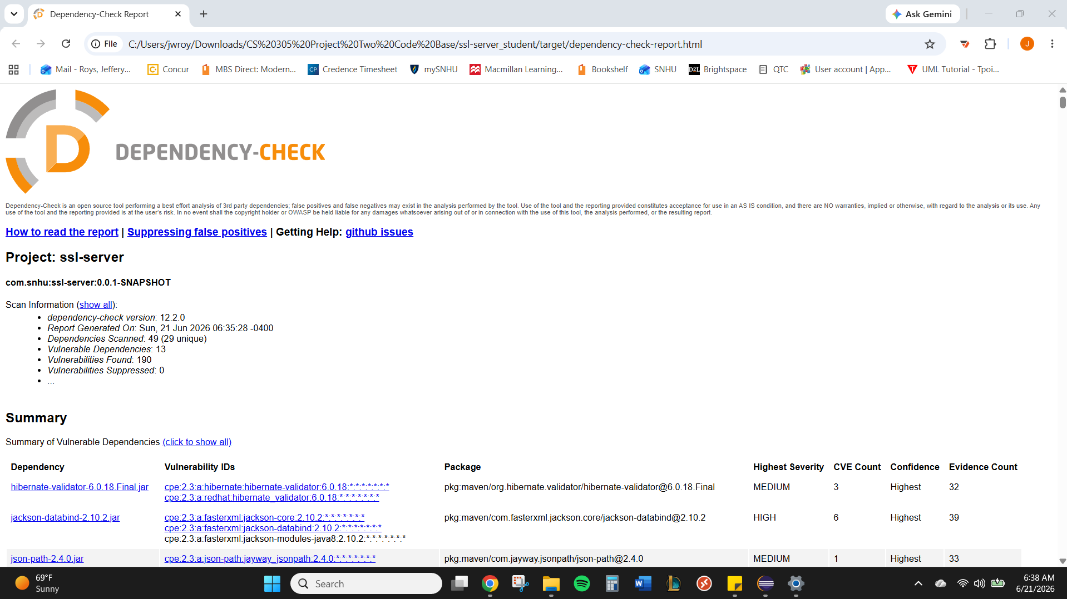

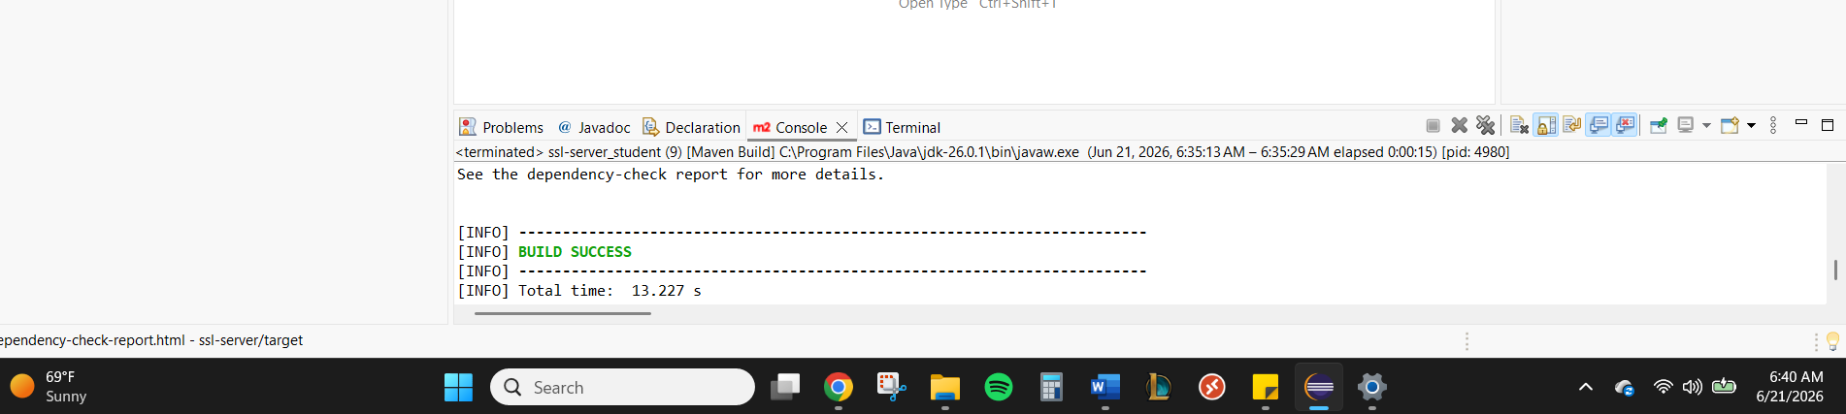

Functional Testing
Insert a screenshot below of the refactored code executed without errors.

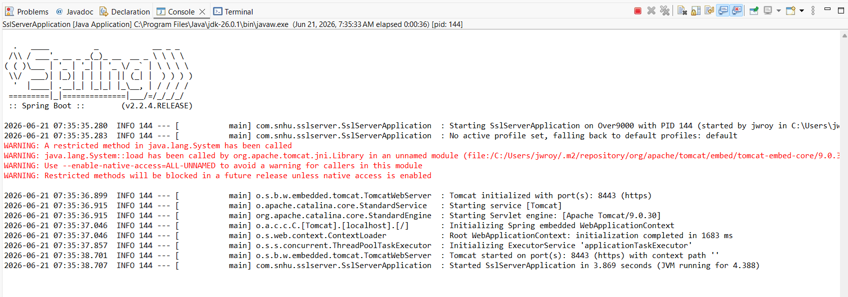

Summary

The application was refactored to add additional security layers for Artemis Financial. First, a SHA-256 checksum endpoint was added to the Spring Boot application. This endpoint allows the user to visit https://localhost:8443/hash and view the original data along with its SHA-256 checksum. This supports data integrity because the checksum can be used to verify that the data has not been changed.
I also generated a self-signed certificate using Java Keytool and configured the application.properties file to use HTTPS on port 8443. This changed the application from plain HTTP communication to secure HTTPS communication. The certificate and keystore files were stored in the resources folder so the application could load them when it starts.

Using the vulnerability assessment process flow diagram, the main areas reviewed in this project were cryptography, client/server communication, APIs, code quality, and secure coding practices. The cryptography area was addressed through the SHA-256 checksum. The client/server area was addressed by enabling HTTPS. The API and code quality areas were reviewed by testing the /hash endpoint and running OWASP dependency-check.

The dependency-check scan was also completed as a secondary static test. The report showed that some older project dependencies have known vulnerabilities. These vulnerabilities are related to the existing Spring Boot dependency versions in the provided code base, not the checksum code that was added. In a production environment, the next step would be updating the affected dependencies and retesting the application.

Industry Standard Best Practices

I applied secure coding best practices by using a current and widely accepted hash algorithm instead of an outdated algorithm such as MD5 or SHA-1. SHA-256 provides a stronger checksum because it creates a 256-bit hash value. I also kept the checksum logic simple and readable so the code can be reviewed and maintained more easily.

I also applied secure communication best practices by configuring the application to use HTTPS instead of HTTP. The self-signed certificate allowed the application to run locally over HTTPS and demonstrate secure communication. For a production system, Artemis Financial would use a certificate issued by a trusted certificate authority instead of a self-signed certificate.

Another best practice was using OWASP dependency-check to review third-party dependencies. This helped identify known vulnerabilities in the existing libraries used by the project. Running dependency-check is important because secure code also depends on secure libraries and frameworks.

These best practices are valuable to Artemis Financial because the company handles sensitive financial information. Secure coding, HTTPS communication, checksum verification, and dependency scanning help reduce risk, protect client data, and support trust in the application. These steps also support the idea that security is everyone’s responsibility because developers must think about security while writing and testing software.

